Code file
for
Car number Plate Detection Model

Submitted by

Khushi Tomar
(Roll No: 25CSE1003000526)

Under the supervision of

Mr. Shobhit


IILM University, Greater Noida, Uttar Pradesh
(November 2025)

1. Uploading dataset taken from kaggle

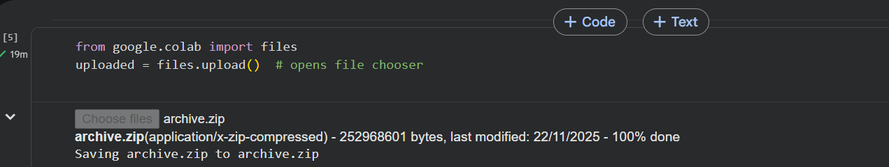

2. Unzip the file/dataset

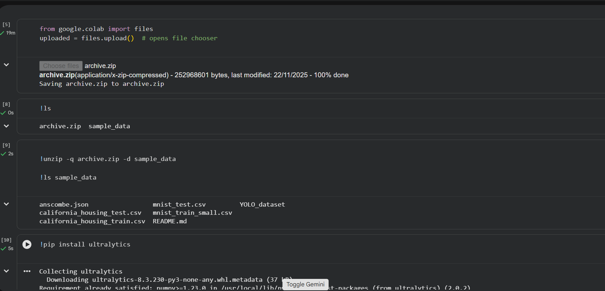

3. Install ultralytics for YOLOv8 model

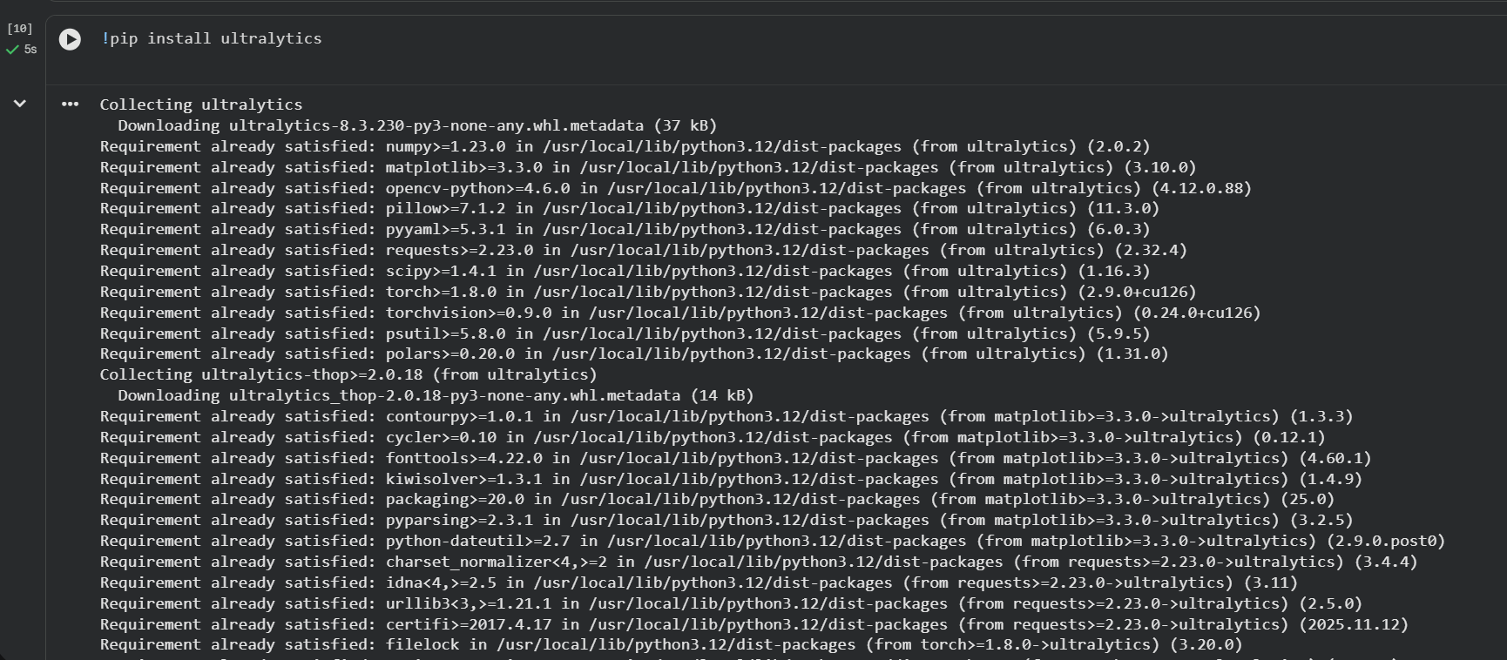

4.Import yolov8 from ultralytics

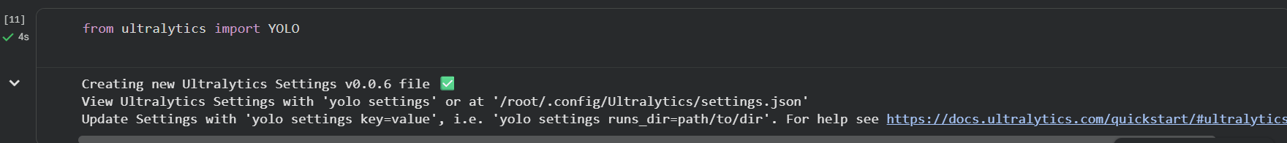

5. Update Datapath name

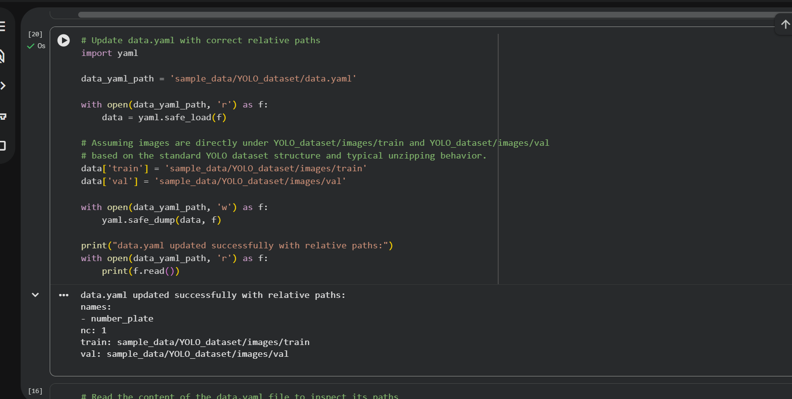

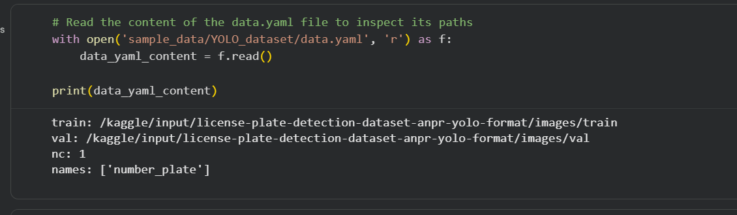
6. Train the model using yolov8
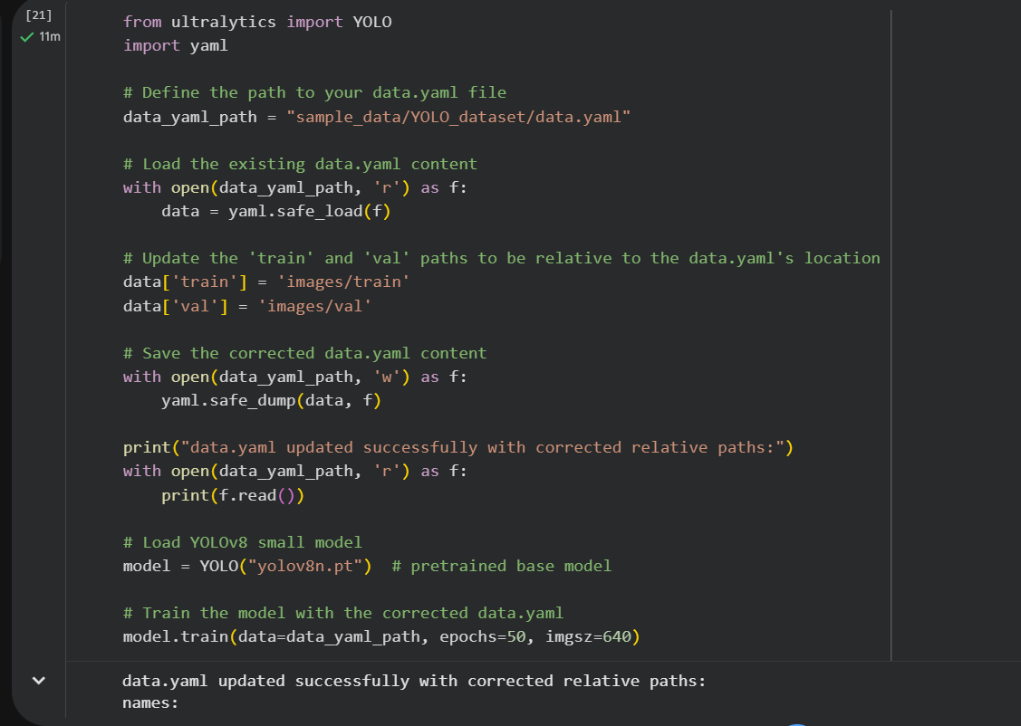
Verifying model is trained
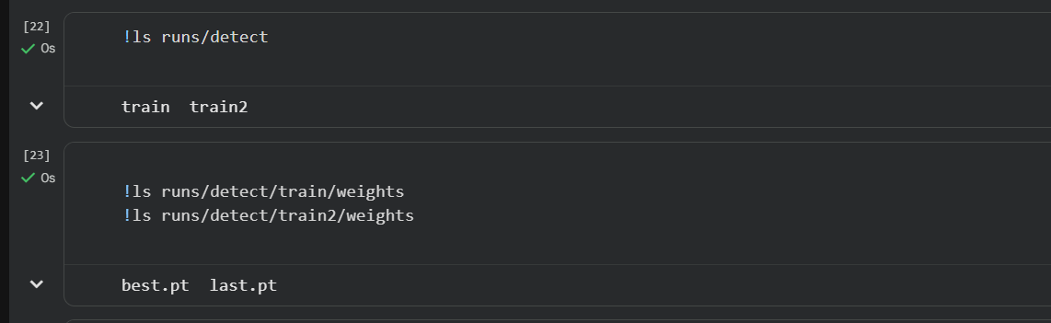

7. Run the model
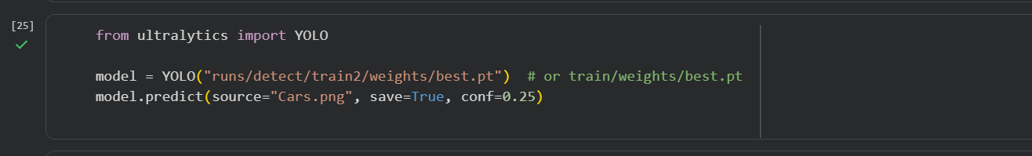
8. Check the accuracy of the model
